RESOLUTION NO.__________

RE: CERTIFICATE OF APPROPRIATENESS UNDER THE
PROVISIONS OF THE ACT OF THE PENNSYLVANIA
LEGISLATURE 1961, JUNE 13, P.L. 282 (53
SECTION 8004) AND BETHLEHEM ORDINANCE NO.
3952 AS AMENDED.

WHEREAS, it is proposed to secure a COA for installation of the company’s logo in the storefront at 831 East Fourth Street.

NOW, THEREFORE, BE IT RESOLVED by the Council of the City of Bethlehem that a Certificate of Appropriateness is hereby granted for the proposal.

Sponsored by: (s)

(s)

ADOPTED BY COUNCIL THIS DAY OF

(s)
President of Council

ATTEST:

(s)
City Clerk

HISTORIC CONSERVATION COMMISSION

CASE #647 -- It is proposed to install the company’s logo in the storefront at 831 East Fourth Street.
OWNER/APPLICANT: DG Commons / Dale Hicklin

The Commission upon motion by Mr. Roeder and seconded by Mr. Cornish adopted the proposal that City Council issue a Certificate of Appropriateness for the proposed work as described herein:

- The proposal to retain the existing adhesive vinyl company logo and adhesive white vinyl lettering in various sizes and font styles depicting the company name, slogan with provided services, telephone number and website information in the storefront window at 831 East Fourth Street was presented by Femi Amintoya and Isaac Vidol.
- With the exception of the company logo, telephone number and/or website information, existing lettering in the storefront window shall be removed.
- New vinyl lettering of various items originally installed in the storefront window (also potentially including hours of operation) shall be re-formatted for installation on the inside glass surface of the existing entrance door; Applicant is encouraged to use warm white or ivory lettering rather than the current bright white color.
- Prior to fabrication and installation, a mock-up of proposed lettering is to be submitted to the Historic Officer and to the Chair of HCC for review.
- The motion for the proposed work was unanimously approved.

JBL: jbl
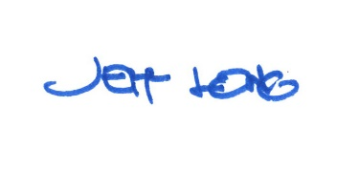

By:

Date of Meeting: May 21, 2018 Title: Historic Officer

